Data Science ̶ Part II

# Considering multiple random variables, explain the chain rule decomposition for the joint probability. Provide examples of different statistical relationships between random variables. Explain the Markov chain of the first and second orders.

+ TP 5

# Give the definition of entropy for discrete random variables. Explain the main properties of entropy. Explain the entropy of binary random variables.

# Explain the joint and conditional entropy for discrete random variables. Explain the chain rule for entropy.

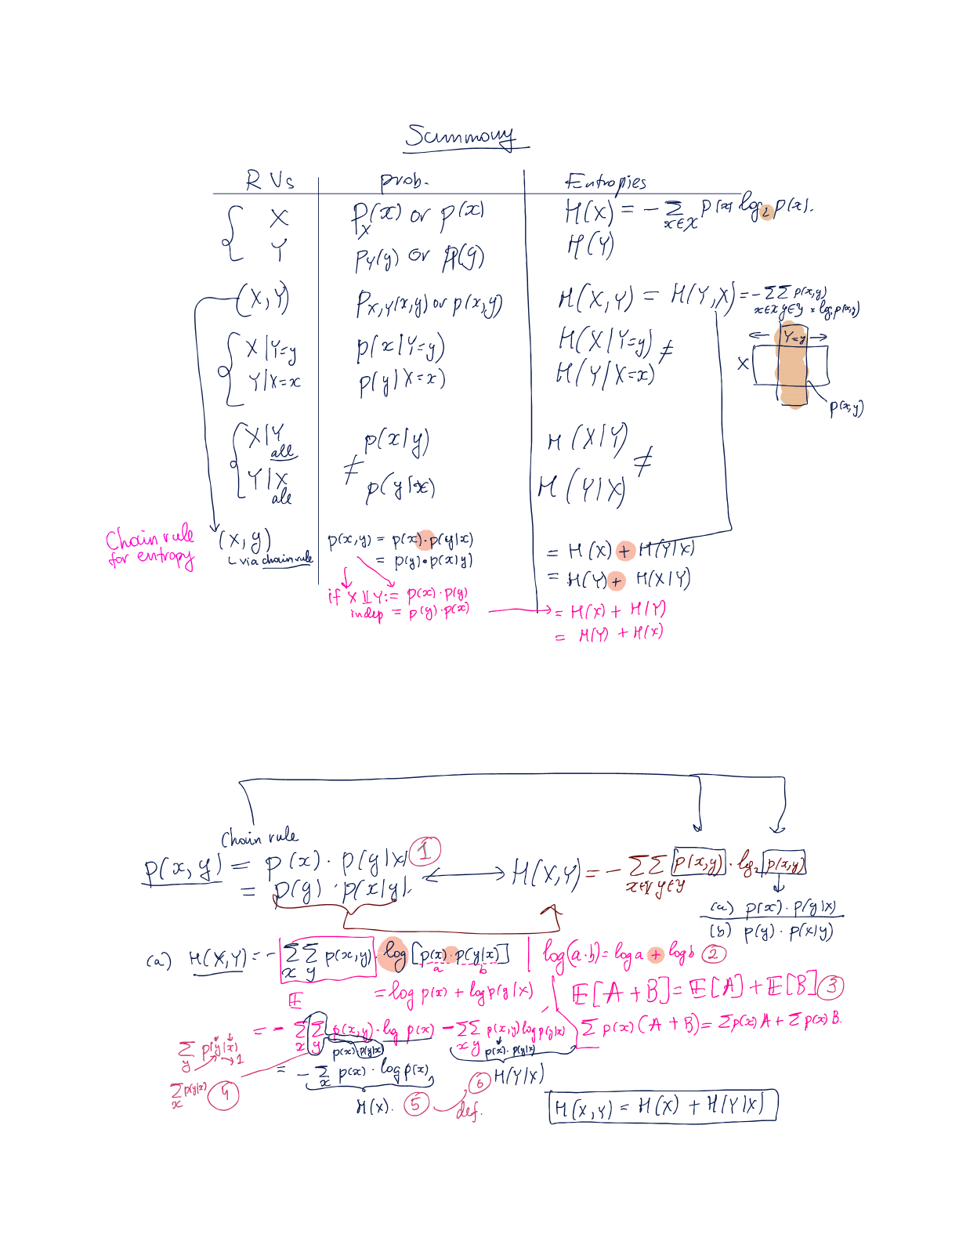

# Explain the properties of entropy on the examples of conditional entropy H(X|Y) and joint entropy H(X,Y). Use Venn diagrams.

# Explain the relative entropy, its properties and provide some examples of its usage.

# Chart Description automatically generatedExplain the cross-entropy and provide some examples of its usage. Show a link between the cross-entropy and relative entropy.

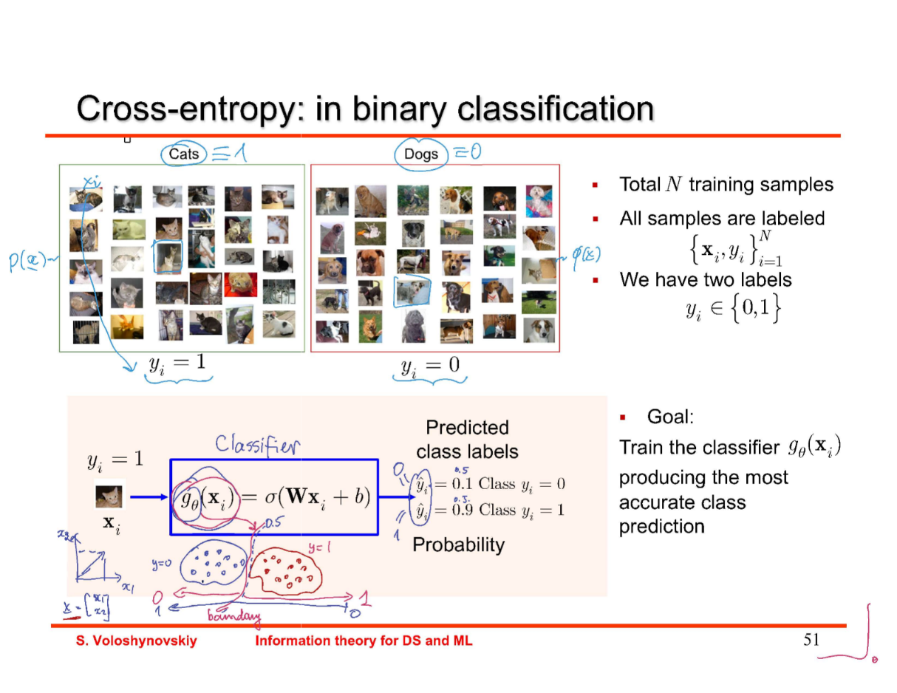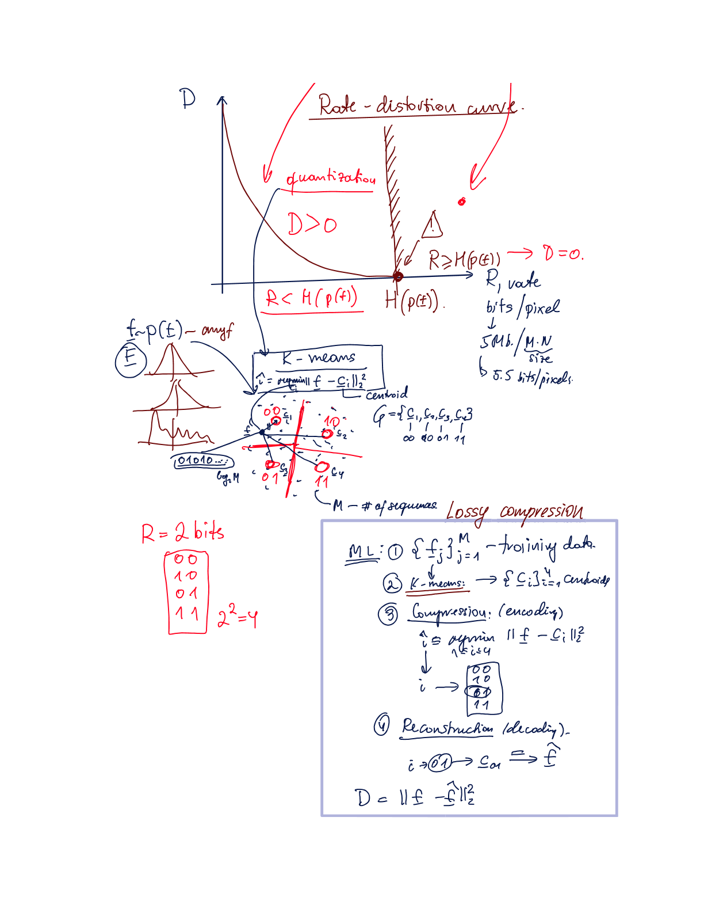

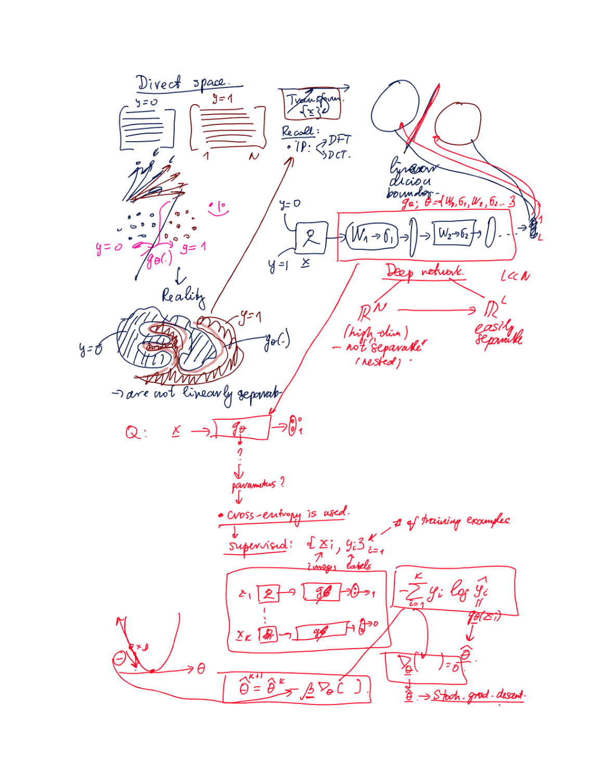

# Give the definition of mutual information. Explain the Venn diagram. Demonstrate different expressions for mutual information via entropies and relative entropy.

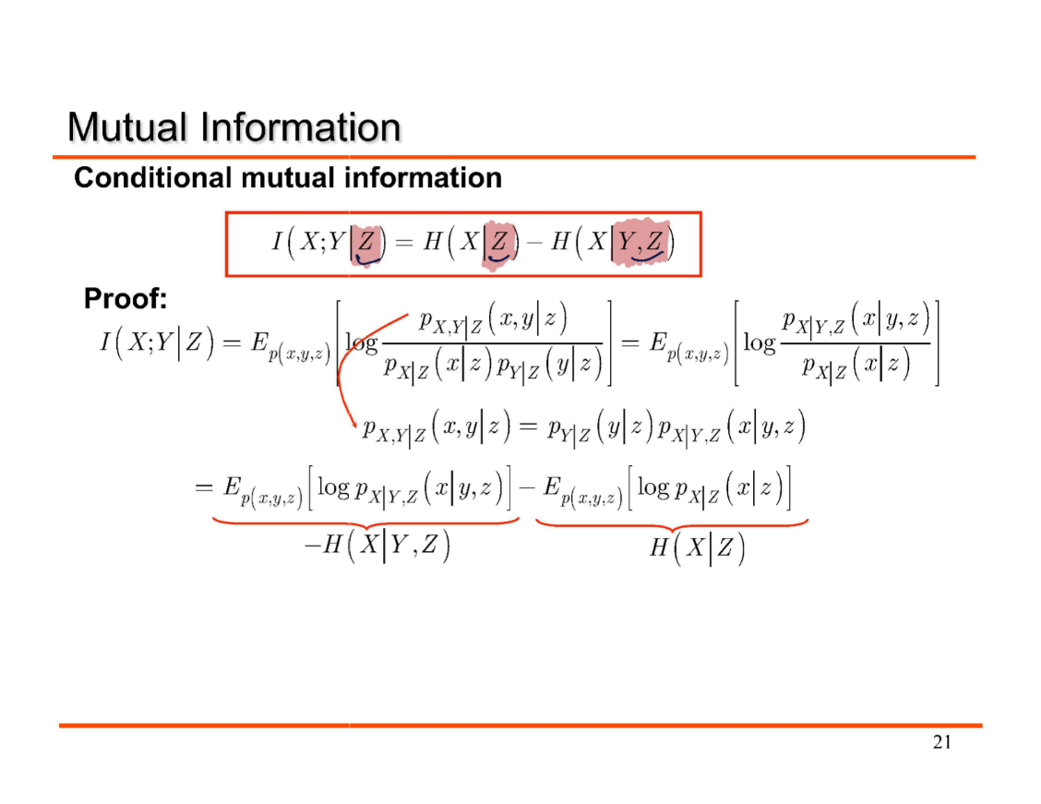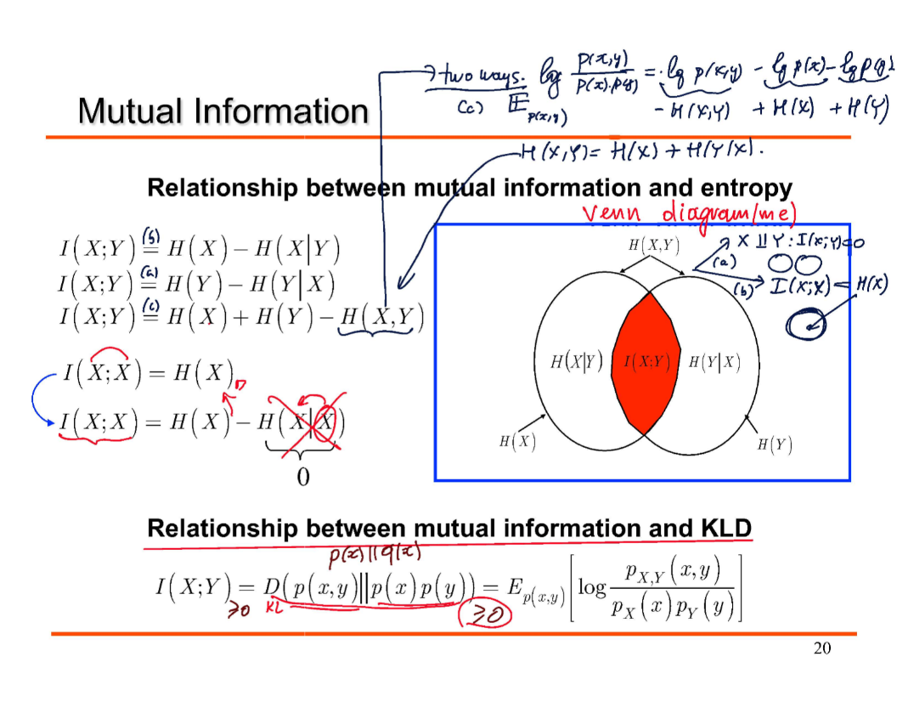

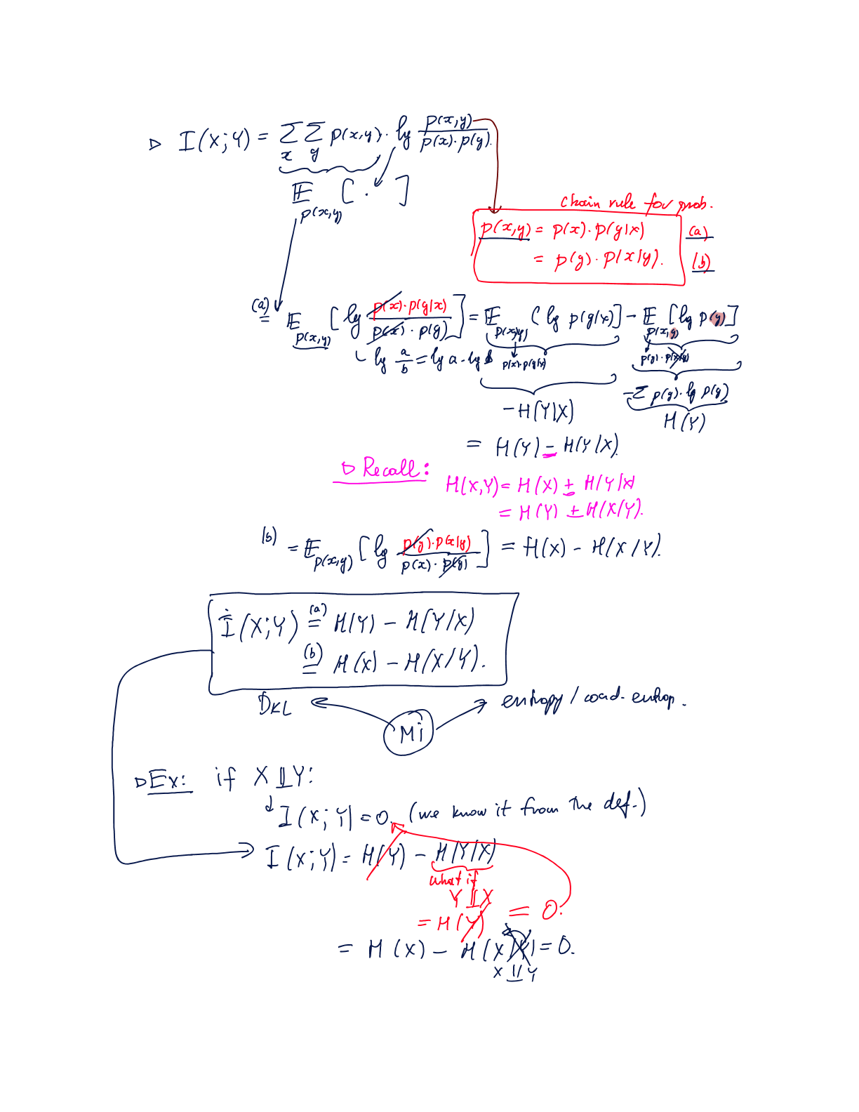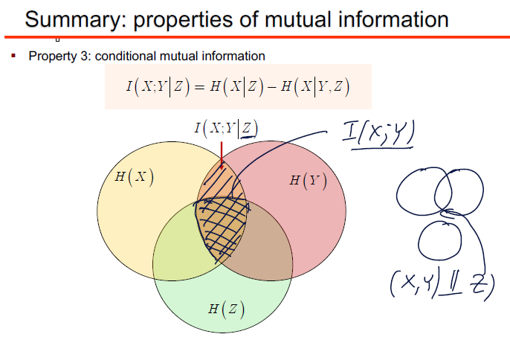

# A picture containing chart Description automatically generatedExplain the chain rules for probability, entropy and mutual information.

# Explain the data processing inequality. Exemplify its practical usage and significance.

# Explain the differential entropy for continuous random variables. Explain the properties and differences to the entropy for the discrete random variables.



